A new, smaller Payments Card

The payments cards are manufactured according the iso standard ISO/IEC
7816-1 which in turn are based on standard ISO/IEC 7810.
Indeed, the payments cards we are using today have the same physical
aspect of the first payments card issued more than 60 years ago, in
the fifties!
The standard regulates not only the way cards are designed, but also
the way millions of card readers need to be designed in order to be
able to read payment cards to allow transactions to happen.
Their nature (PVC) and the fact that they require constant re-issuing
represent an additional challenge to environmental sustainability and
it’s safeguard.
Since a few years, several cards manufacturers have started using
sustainable and (partially) recyclable materials, but such companies
are still only a few in numbers within the vast card manufacturing
industry.
Despite all these efforts aiming at a more sustainable production
cycle, we must however consider that:
- Six billion payments cards are produced each year, typically from PVC
- These cards are replaced on average every three to four years, with
discarded cards going to landfills across the world

As such, what is really needed is systemic change based on disrupting
actions that tackle a system which is half a century old, without
jeopardizing card acceptance overall.
The Idea
An immediate solution to decrease the amount of plastic used in cards
would be to change the physical dimensions of the card itself,
reducing it by one third of its actual dimension.
Only with such action, shared by the issuing circuits, would allow for
a quick reduction in PVC material used.
This would happen without operational traumas as it’d only be one step
in the direction towards 100% virtual.
While we wait for such transition (physical —> virtual to a wallet)
we could in such way become more sustainable, as This new card would
maintain the same functionalities (magnetic, chip and contact-less) and just differ in terms of physical dimension.
Such solution would not interfere with the (now - pandemic times - more
than ever crucial) contactless payment option, since this is
independent from the dimension of the card.
Of course, guidance will need to be issued to help such transition and
to guarantee transparency in cases where there is the need for a
“physical” reading. In particular, updating terminals or delivering to the POS premises a Card- adapter in order to let an easy usage of the new card in the old card-readers (similarly to how you work with memory or telephone SIM adapters).

By the way, the proposal is for a new standard layout to be used not only for payments cards but for identification cards in general (loyalty, ID-card …)
Below illustrations of:
- the front and the back of such new, smaller, more sustainable card
- the new cards vs. the old, bigger ones
- the possible ISO standard update coherent with such new cards ID-1Reduced

- the front and the back of such new, smaller, more sustainable card
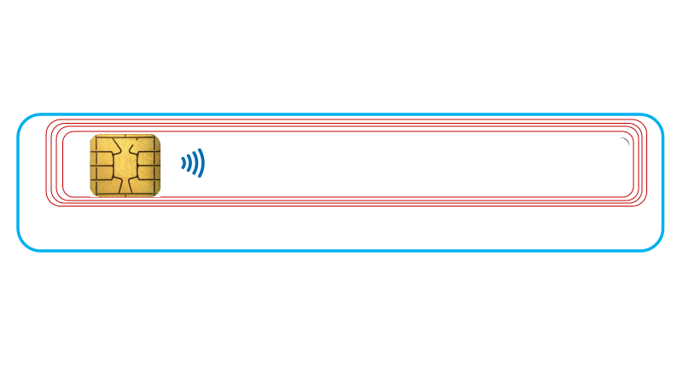
- the new cards vs. the old, bigger ones

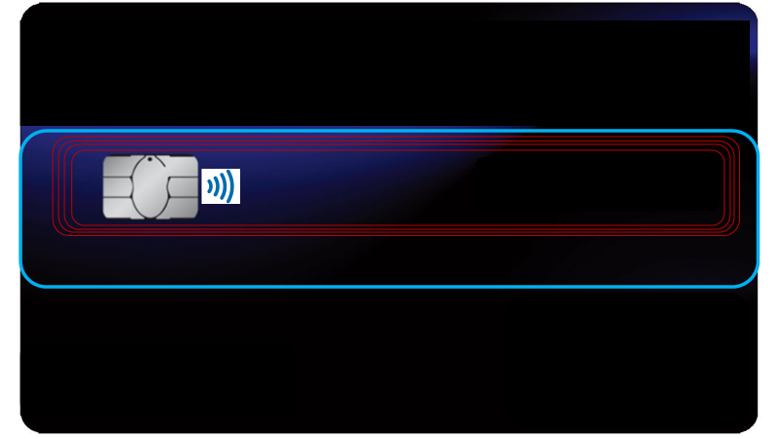

- the possible ISO standard update coherent with such new card ID-1R

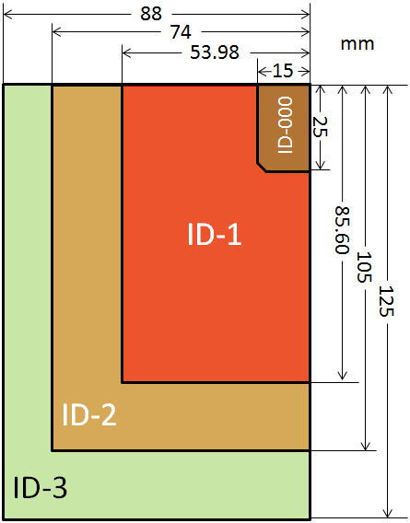
18
ID-1R

